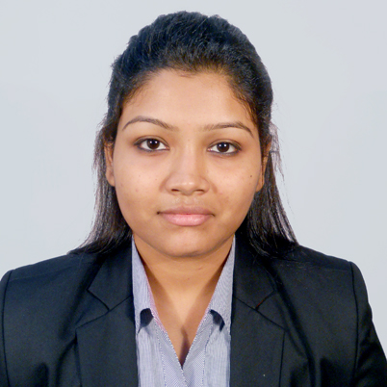
Contact Address: 2/74 Vidyasagar Upanibesh Kolkata 700047
Contact Number :9674078093
Email-Id: chandrima.tapader@gmail.com

Chandrima Tapadar

CAREER ASPIRATION
- Result driven individual, seeking assignments in Human Resources &/or Marketing Management position where my professional experience and education will allow me to make an immediate contribution as an integral part of a progressive company

- I aim to utilize proven people-oriented skills to develop and promote a positive working environment in the organisation

SYNOPSIS

- Successfully completed two years full-time Post graduate programme in Planning and Entrepreneurship, Leading to a MBA degree from International Management Institute, Belgium–with dual specialization in Human Resource Management & Marketing Management from IIPM, with zeal to excel in the field management of Human Capital.

SCHOLASTICS

- Integrated BBA & MBA with dual specialization in Marketing Management & Human Resource Management from IIPM, in 2014 with 61.64% marks
- Higher Secondary (12th ) in Arts & Humanities from J.S.B.V in 2009 with 74% marks
- Madhyamik (10th ) from J.S.B.V in 2007 with 65% marks

CAREER INTERESTS

- Sales & Marketing  - Human Resource  - Administration  - Public Relations | - Corporate Communication  - Recruitment  - Training & Development  - Human Resource Information System

INDUSTRIAL EXPOSURE

- Organisation : Infocom Network Ltd. (Trade India)

Designation : Senior Executive-Key Account (Meeting with existing clients of the company and approached them for the website related products)
Location : Kolkata
Duration : January 2015 till April 2015

- Organisation : Associate Engineers

Designation : Sr. Marketing Executive (meeting with clients and convince them for real-estate property )
Location : Kolkata
Duration : July 2015 to June 2016

TRAININGS UNDERTAKEN

- Organisation : Berger Paints

Designation : Management Trainee
Project Title : Competitive Analysis of Berger Paints and Developing Business by finding Out Non Berger Applicators in Kolkata

Location : Kolkata
Duration : April 2013 till June 2013 (During MBA)

- Organisation : Standard Chartered Bank

Designation : Management Trainee
Project Title : Comparative Analysis between Different Foreign Banks.
Location : Kolkata
Duration : March, 2012 till April, 2012 (During BBA)

SKILL SETS

- Proficient in Windows 2007,XP & Vista
- Proficient in MS – OFFICE 2000, 2003 & 2007
- Internet Proficient

PERSONAL DOSSIER

Date of Birth : November 23, 1989

Marital Status : Married

Sex : Female

Language :
- English,
- Bengali
- Hindi
Interests :
- Singing
- Listening to Music
- Internet Surfing
- Cooking
- Meeting new people

DECLARATION

I want to grow into a professional world and use the Industry’s knowledge and experience to develop my attributes and be successful and prove myself, worth it .My long term vision is to see myself among the Top Authorities, for the organization I serve.

